Lesson 1: Introduction to Python: Fundamentals and Setup

Overview
In this guided practice, you will take on the role of a software engineering intern at a fast-growing startup. Your first assignment is to develop a comprehensive Employee Financial Insights System that collects and analyzes employee salary data. You will work hands-on with Python variables, data types, operators, indentation, user input, and output. Your task is to write code and ensure it follows best practices, handles errors, and provides meaningful insights based on user input and output.

Instructions
- Work individually to complete each coding task
- Use Jupyter Notebook as your development environment
- Spend approximately 20 minutes completing all tasks
- Document your observations and strategies in the worksheet provided for review

Tasks
Scenario: You have joined a tech startup as a software engineering intern, and your manager has given you the task of developing an Employee Financial Insights System as the company aims to improve financial awareness among employees and assist HR in salary planning. Your task is to collect employee salary data and provide valuable financial insights, including annual earnings, tax deductions, salary growth projections, and savings estimations. This marks the first step toward building an intelligent HR analytics tool for better decision-making.
Steps to be followed:
- Set up and collect employee data
- Calculate salary and generate financial insights
- Display and format data properly

Tools required: Jupyter notebook
Dataset to be used: None

Discussion questions (optional)
If time permits, discuss the following questions:
- What additional financial metrics can be included in this system to provide deeper insights?
- How can this program be expanded to include more HR functionalities in the future?

Answer Key
Step 1: Set up and collect employee data
- Open Jupyter Notebook and create a new notebook named employee_financials.ipynb and click on Rename.
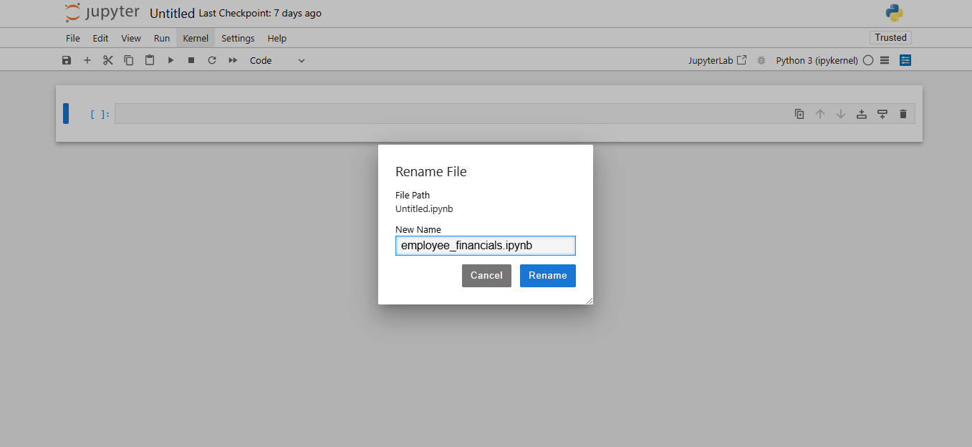

- Click the code dropdown, select Markdown, and type the following purpose of the notebook in the Markdown cell:

Employee Financial Insights System. This program collects and analyzes employee salary details to provide financial insights.

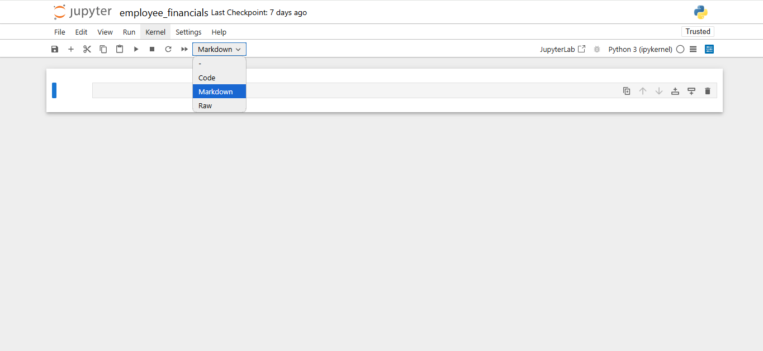

- Add a code cell that prints a welcome message using the following print() function:
print(‘---------- Welcome to the Employee Financial Insights System! ----------')

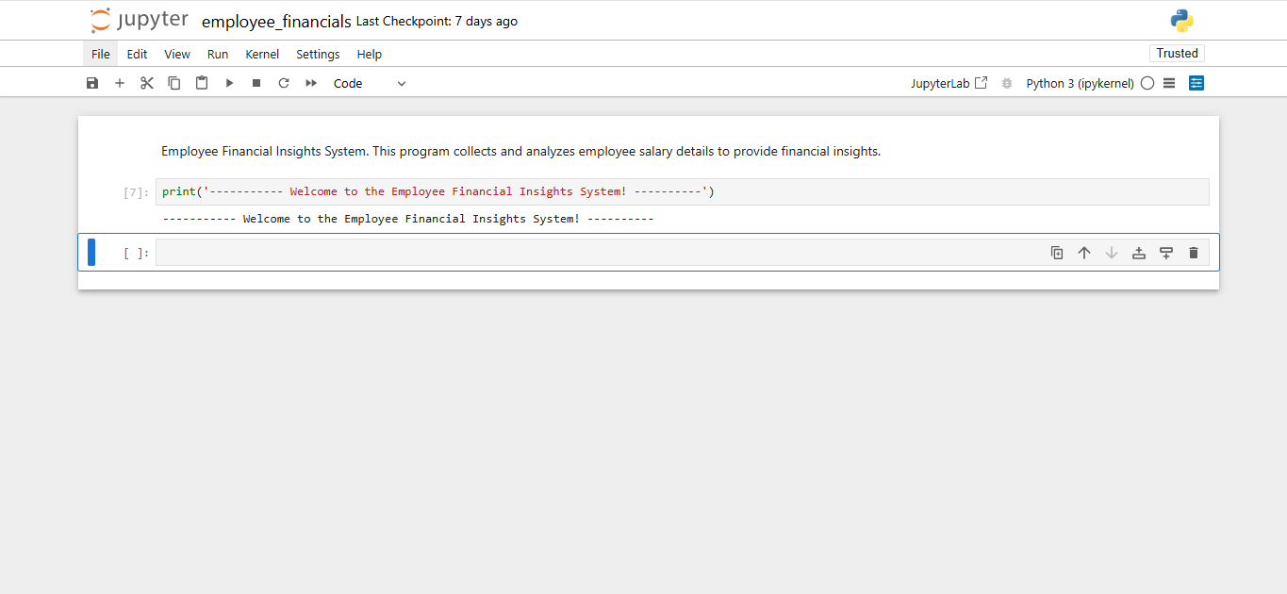

- Collect employee data using the following input() function:

# Collect user input
name = input("Enter full name: ")
department = input("Enter department: ")
experience = input("Enter years of experience: ")
salary = input("Enter current salary ($): ")

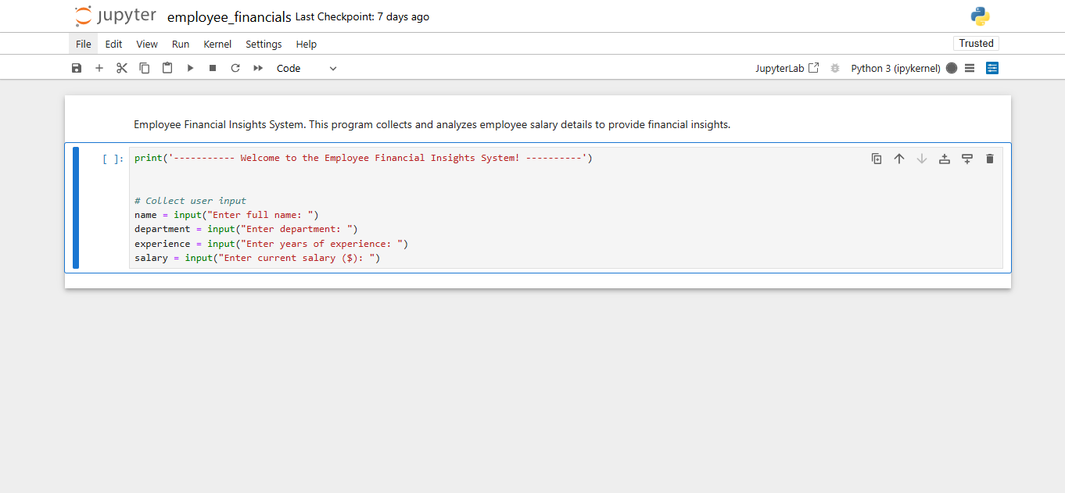

- Convert numerical values appropriately (int() for experience and float() for salary) using the following script:

# Convert numerical values
experience = int(experience)
salary = float(salary)

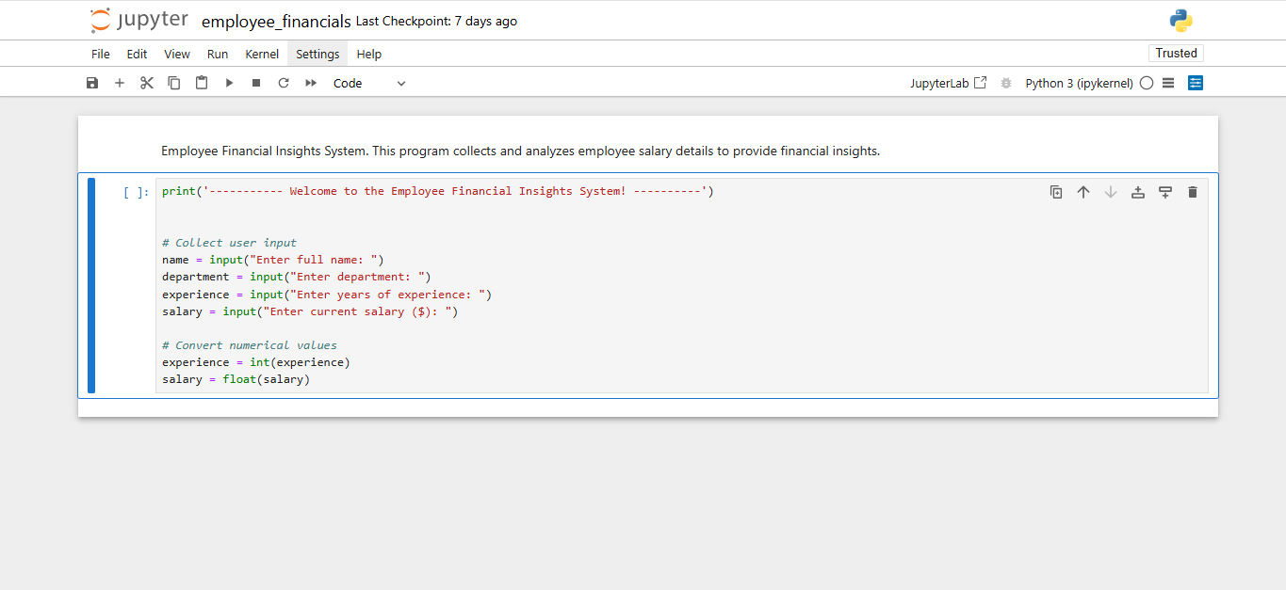

Step 2: Calculate salary and generate financial insights

  - Use the following arithmetic operators to compute the annual salary:

# Perform salary calculations
annual_salary = salary * 12 # Compute annual salary
tax_deduction = salary * 0.12 # Apply 12% tax
take_home_salary = salary - tax_deduction # Post-tax salary

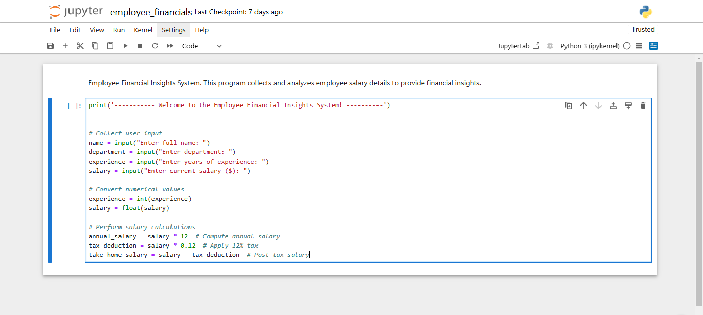
  - Calculate the estimated salary growth over the next 5 years based on a 5% annual increment using the following script:

# Estimate salary growth over the next 5 years
growth_rate = 0.05 # 5% annual increment
year_1 = salary * (1 + growth_rate)
year_2 = year_1 * (1 + growth_rate)
year_3 = year_2 * (1 + growth_rate)
year_4 = year_3 * (1 + growth_rate)
year_5 = year_4 * (1 + growth_rate)
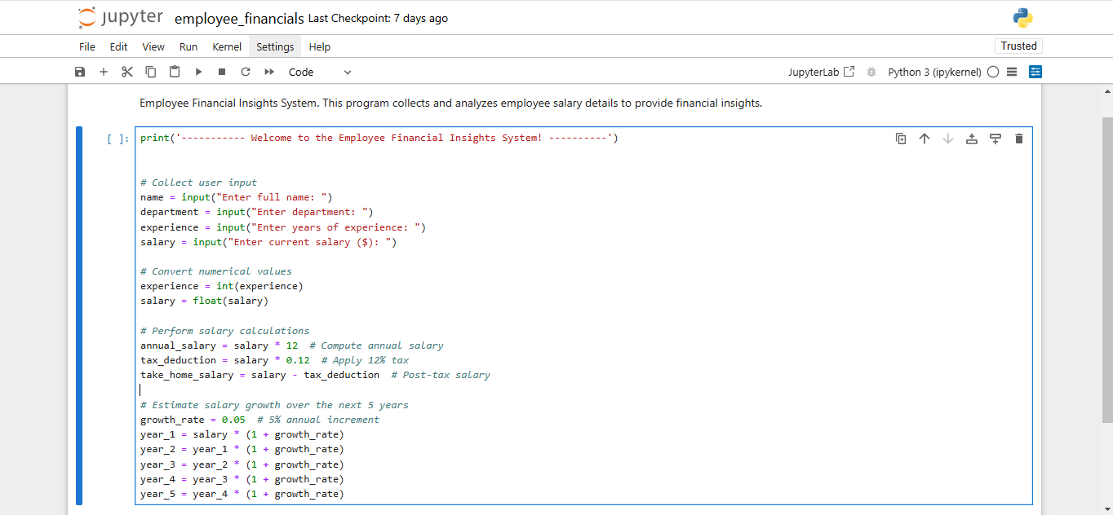

  - Suggest potential savings using the following script, assuming the employee saves 20% of their post-tax salary annually:

# Calculate potential savings assuming 20% of post-tax salary is saved
annual_savings = take_home_salary * 0.20
five_year_savings = annual_savings * 5

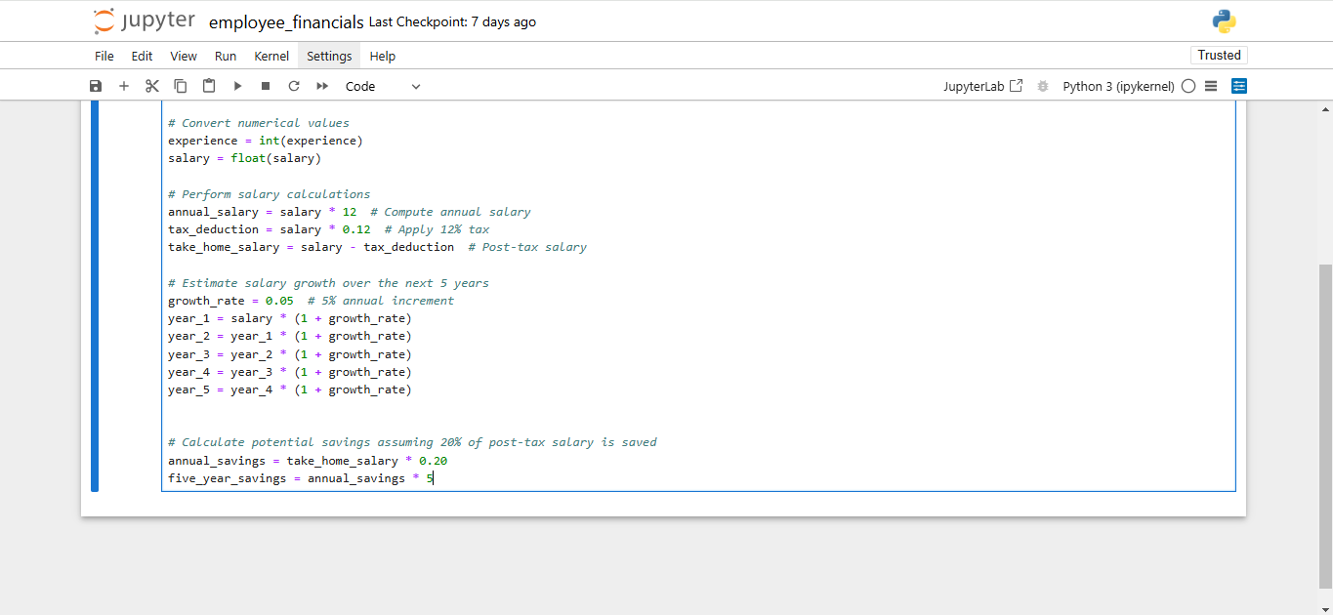

Step 3: Display and format data properly
  - Structure the output to display the employee’s full profile using the following script:

# Display collected data
print("\n--- Employee Financial Profile ---")
print("Name:", name)
print("Department:", department)
print("Experience (years):", experience)
print(f"Current Monthly Salary: ${salary:.2f}")
print(f"Expected Annual Salary: ${annual_salary:.2f}")
print(f"Estimated Post-Tax Monthly Salary: ${take_home_salary:.2f}")
print(f"Projected Salary Growth (Next 5 Years):")
print(f" Year 1: ${year_1:.2f}")
print(f" Year 2: ${year_2:.2f}")
print(f" Year 3: ${year_3:.2f}")
print(f" Year 4: ${year_4:.2f}")
print(f" Year 5: ${year_5:.2f}")
print(f"Potential Annual Savings: ${annual_savings:.2f}")
print(f"Projected 5-Year Savings: ${five_year_savings:.2f}")

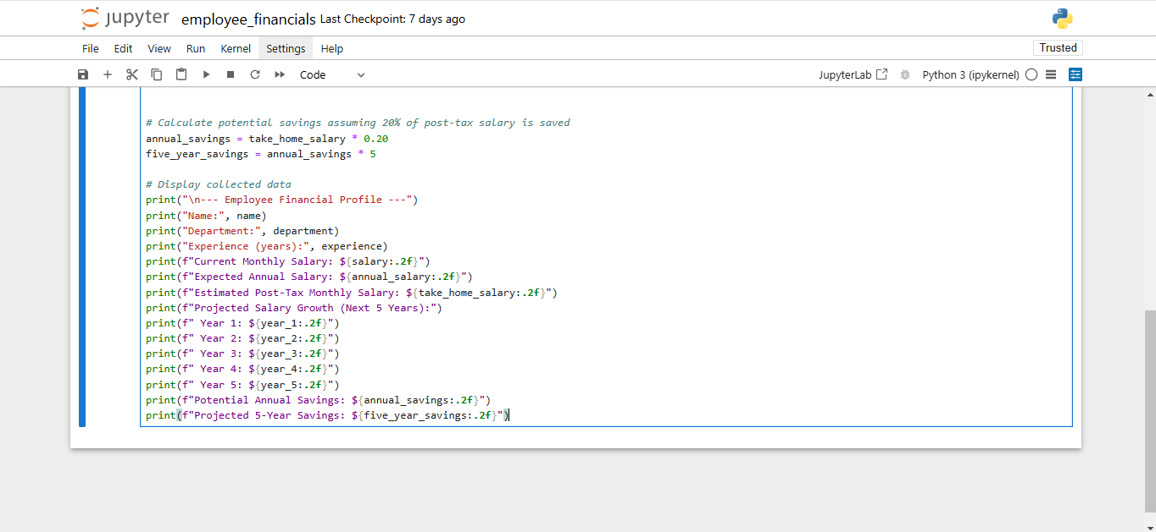

  - Press Shift and Enter to run the current cell. Then, enter the details as prompted.
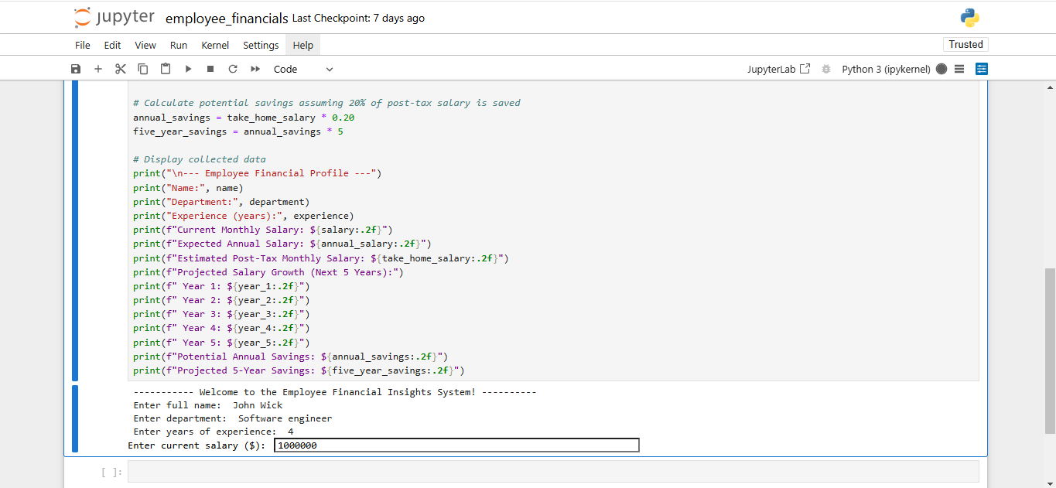

The following output is generated successfully:

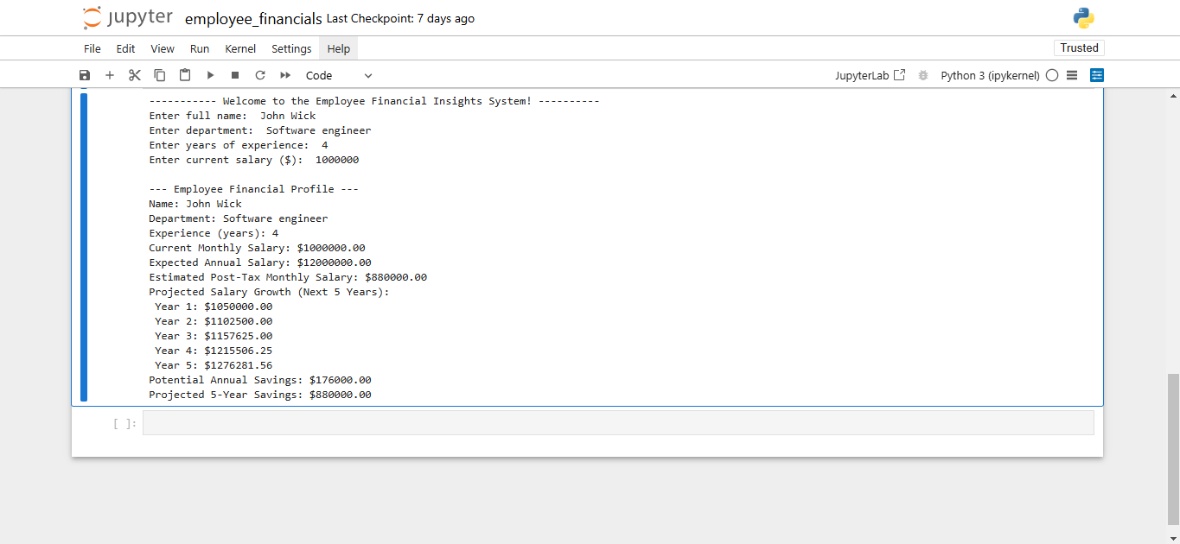

In this guided practice, you explored how Python can be used to analyze employee financial data, providing valuable insights for both employees and HR professionals. Developing an Employee Financial Insights System taught you how to collect structured data, perform calculations, and format financial projections using Python operators. This exercise demonstrated how automation can enhance financial awareness, improve decision-making, and streamline HR processes. Mastering these skills will enable you to build more data-driven applications in the future, contributing to smarter workplace solutions and better financial planning.

Discussion questions (optional)
If time permits, discuss the following questions:

1. What additional financial metrics can be included in this system to provide deeper insights?
Answer: To gain a more comprehensive understanding of employee financial data, additional metrics can include:
- Cost of living adjustment: Evaluates salary inflation and geographic living costs
- Salary-to-industry benchmark: Compares employee salaries with market rates based on experience and department
- Loan repayment analysis: Estimates how much of an employee’s salary can be allocated toward loan or mortgage payments
- Investment growth projection: Suggests potential long-term wealth growth based on different investment rates
- Retirement contribution estimation: Calculates how much employees should allocate to retirement funds for long-term financial security

2. How can this program be expanded to include more HR functionalities in the future?
Answer: This system can be expanded to include:
- Performance-based salary projection: Integrate employee performance ratings to predict future salary increments
- Employee benefits optimization: Provide recommendations for benefits like insurance, stock options, and bonuses
- Work-life balance index: Factor in work hours, vacation days, and burnout risk to suggest salary adjustments
- HR analytics dashboard: Build a visual dashboard to monitor salary distribution, turnover risk, and employee satisfaction trends
- Tax filing assistance: Offer pre-filled tax forms and deductions to help employees manage their annual tax filings

